Ideation Phase
Brainstorm & Idea Prioritization Template
Date | 31 January 2026
Team ID | SWTID-2026-1597
Project Name | AI Fit Track API – Personalized Fitness Tracking with AI-Powered Insights
Maximum Marks | 4 Marks

Brainstorm & Idea Prioritization:
Our team used a free, open brainstorming session where every member contributed ideas on how to help people track fitness consistently and understand their progress. Ideas were listed without judgement, grouped into themes, and then prioritised by importance and feasibility to arrive at the final solution – AI Fit Track API.
Step-1: Team Gathering, Collaboration and Select the Problem Statement
Role | Member
Team Leader | Nithya Sri S
Team Member | Nithiksha J
Team Member | Nithya Sree KS
Team Member | Nivetha P

Selected Problem Statement: How might we give users a secure, centralised record of their workouts and goals, and turn that raw data into personalised, plain-language guidance?
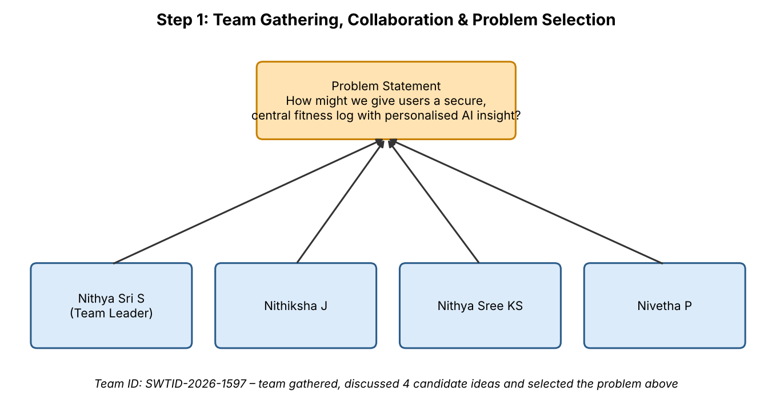
Figure 1: Team gathering and problem selection
Step-2: Brainstorm, Idea Listing and Grouping
Idea Considered | Group | Outcome
Basic workout-logging CRUD API with no AI layer | Data & Logging | Rejected – no added value over note-taking apps
Frontend-only tracker using local device storage | Data & Logging | Rejected – no persistence or security across devices
Chatbot-only fitness assistant with no structured log storage | AI Insights | Rejected – cannot track real progress over time
Full backend with secure auth, workout & goal storage and Gemini AI insights on real data | Security + Data + AI | Selected

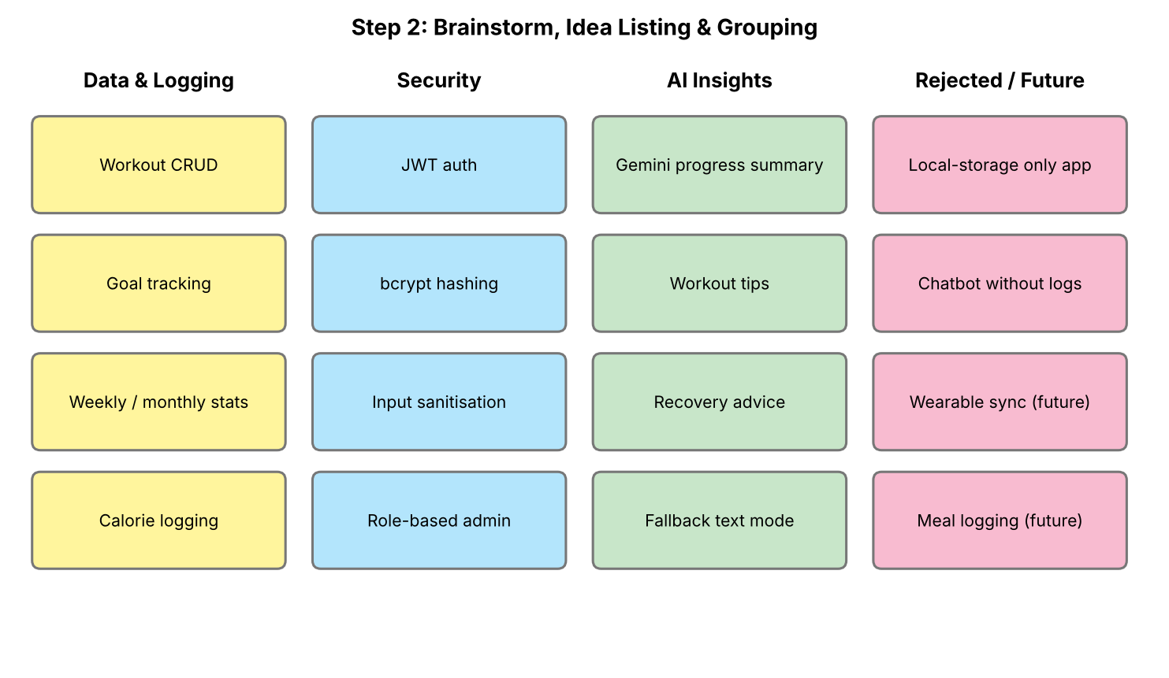
Figure 2: Ideas listed and grouped by theme
Step-3: Idea Prioritization
Each feature was plotted on an Importance vs Feasibility grid. High-importance, high-feasibility items (authentication, workout CRUD, stats aggregation, Gemini AI insights and fallback mode) became the core scope. Wearable sync, meal logging and push reminders were moved to future enhancements.
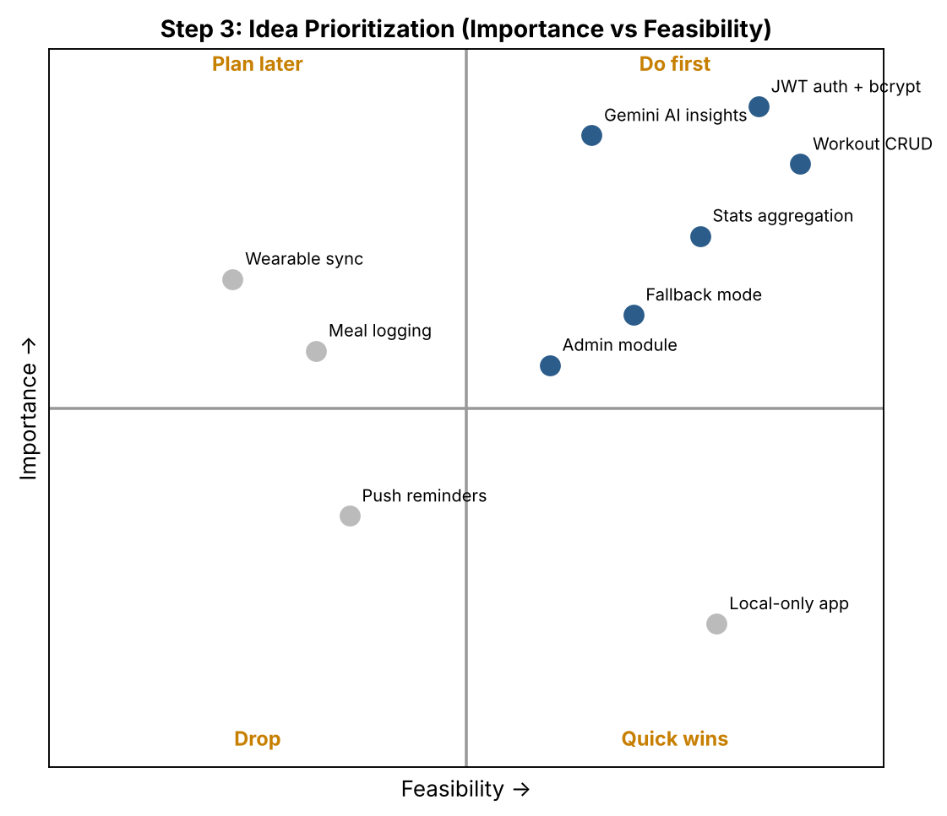
Figure 3: Idea prioritization matrix

